Electrical system model

# 1 System description

Model of the electrical system. It includes the batteries and the network associated. The auxiliary network (servitude, 12V) is considered as a constant load.

# 2 System organization

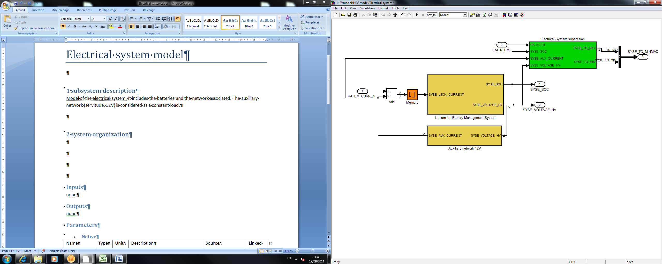

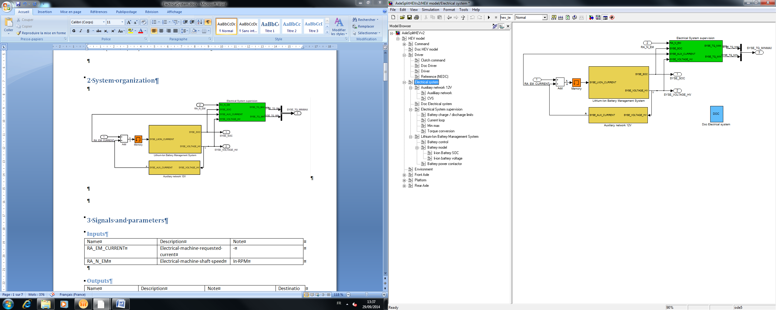

# 3 Signals and parameters

## Inputs

|  |  |  |
| --- | --- | --- |
| Name | Description | Note |
| RA_EM_CURRENT | Electrical machine requested current | - |
| RA_N_EM | Electrical machine shaft speed | In RPM |

## Outputs

|  |  |  |  |
| --- | --- | --- | --- |
| Name | Description | Note | Destination |
| SYSE_SOC | Li-Ion battery state of charge | - | Command |
| SYSE_VOLTAGE_HV | Voltage on the HV network | - | Command, Rear axle |
| SYSE_TQ_MINMAX | Minimum and maximum torque for the electrical system | Normalized torque “to wheel”,  two signal:   * SYSE_TQ_MIN * SYSE_TQ_MAX | Command |

## Parameters

### Native

|  |  |  |  |  |  |
| --- | --- | --- | --- | --- | --- |
| Name | Type | Unit | Description | Source | Linked to |
| syse_aux_current | var | A | Current on the servitude network | Continental |  |
| syse_aux_voltage | var | V | Voltage on the servitude network | Continental |  |
| syse_bat_nominal_capacity_as | var | As | Li-ion nominal capacity in As | Continental |  |
| syse_cdl | var | F | Polarisation capacity | Continental |  |
| syse_dcdc_efficiency | vector | - | DC-DC converter efficiency | Continental | syse_dcdc_in_power |
| syse_dcdc_in_power | vector | W | DC-DC converter efficiency input vector | Continental | syse_dcdc_efficiency |
| syse_electrical_machine_torque_vs_power_speed_nneg | table | Nm | Electrical machine torque | Continental | ra_electrical_machine_speed; syse_em_in_power |
| syse_electrical_machine_torque_vs_power_speed_npos | table | Nm | Electrical machine torque | Continental | ra_electrical_machine_speed; syse_em_in_power |
| syse_em_in_power | vector | W | Elatrical machine torque vs power input vector | Continental | syse_electrical_machine_torque_vs_power_speed_npos; syse_electrical_machine_torque_vs_power_speed_nneg; ra_electrical_machine_speed |
| syse_max_charge_current | vector | A | Maximum charge current | Continental | syse_soc_current_limits |
| syse_max_discharge_current | vector | A | Maximum discharge current | Continental | syse_soc_current_limits |
| syse_nb_cell | var | - | Number of cell in the battery | Continental |  |
| syse_rdl | var | Ω | Polarization resistance | Continental |  |
| syse_rser | var | Ω | Serial resistance of a cell | Continental |  |
| syse_soc_current_limits | vector | V | SOC | Continental | syse_max_charge_current; syse_max_discharge_current |
| syse_soc_initial | var | - | Initial value of the SOC | Continental |  |
| syse_soc_ocv | vector | - | Open circuit voltage input vector | Continental | syse_vocv |
| syse_vocv | vector | V | Open circuit voltage vs SOC | Continental | syse_soc_ocv |

### Inherited

|  |  |  |  |
| --- | --- | --- | --- |
| Name | Type | Unit | Description |
| ra_differential_ratio | var | - | Rear axle differential reduction ratio |
| ra_electrical_machine_speed | vector | RPM | rendement de la machine électrique |
| ra_transmission_efficiency | var | - | Rear axle differential efficiency |

# 4 Subsystems description

Auxiliary network 12V:

Describe the auxiliary network and the DC/DC converter. The power consumption of the auxiliary network is seen as a current loss.

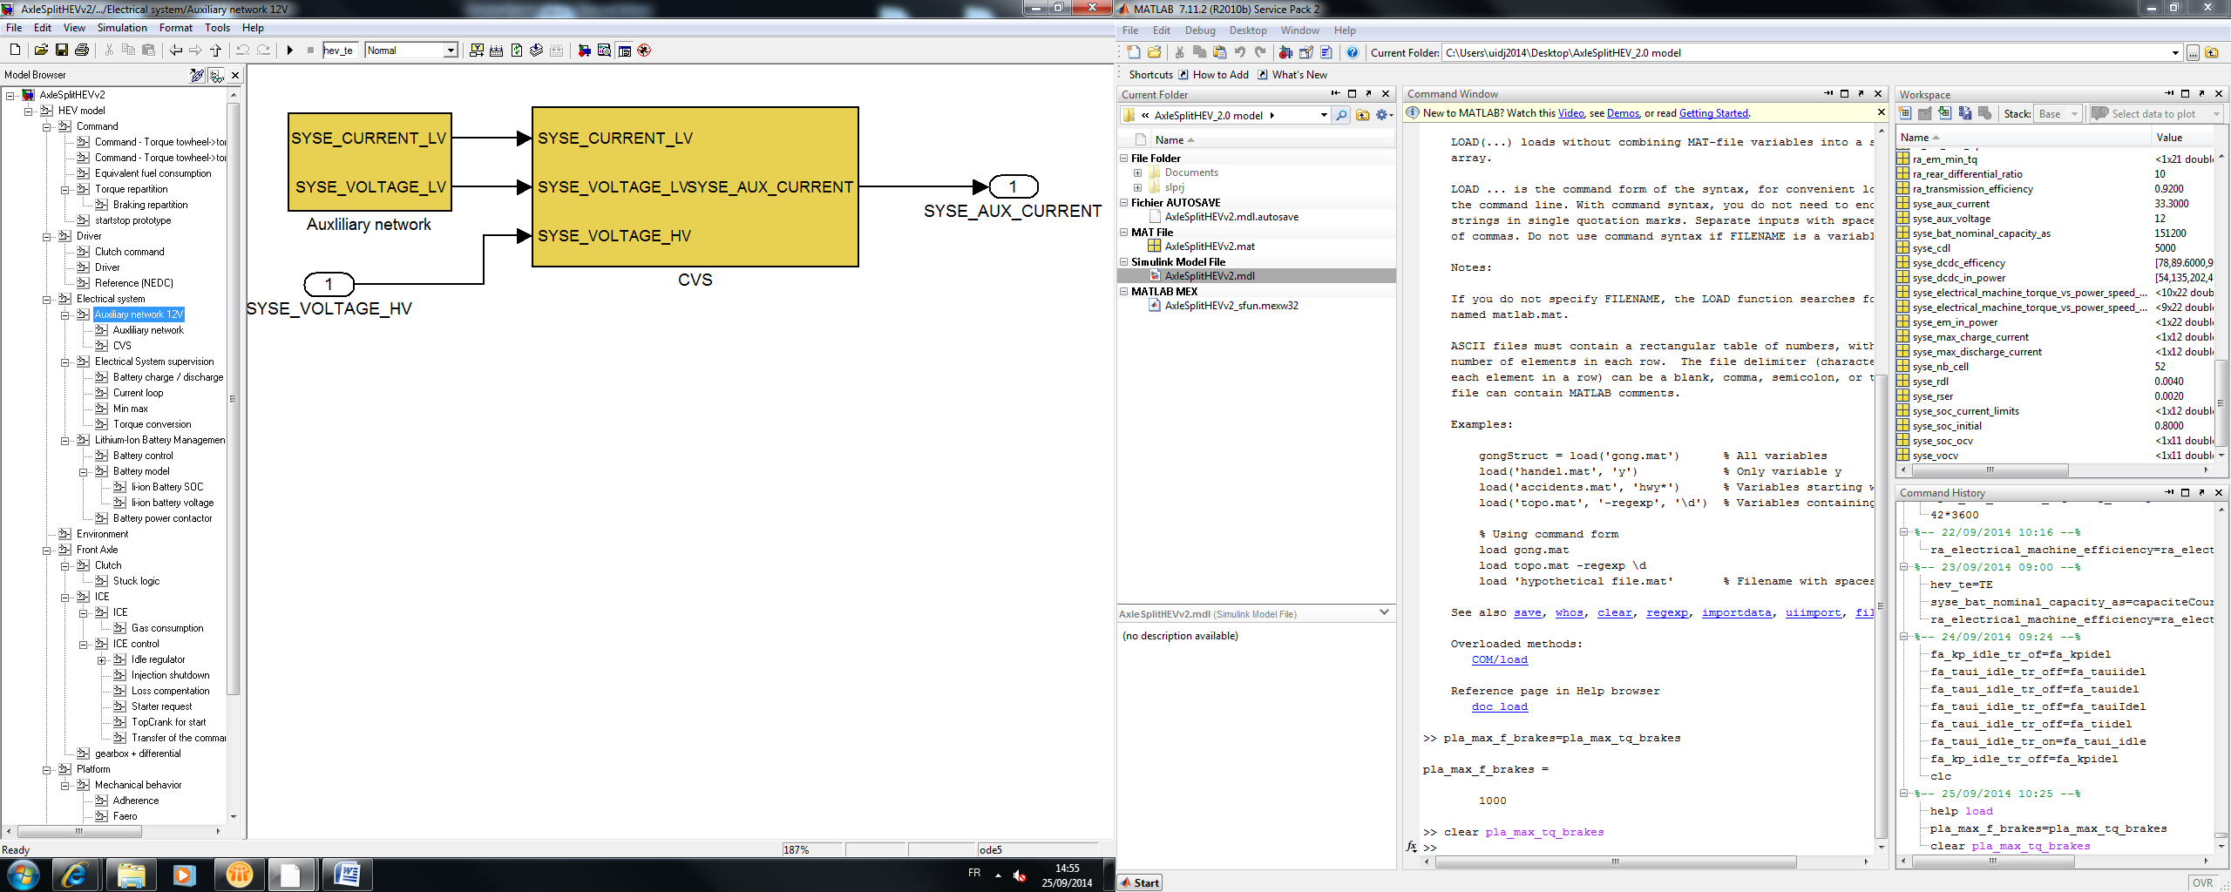

Auxiliary network:

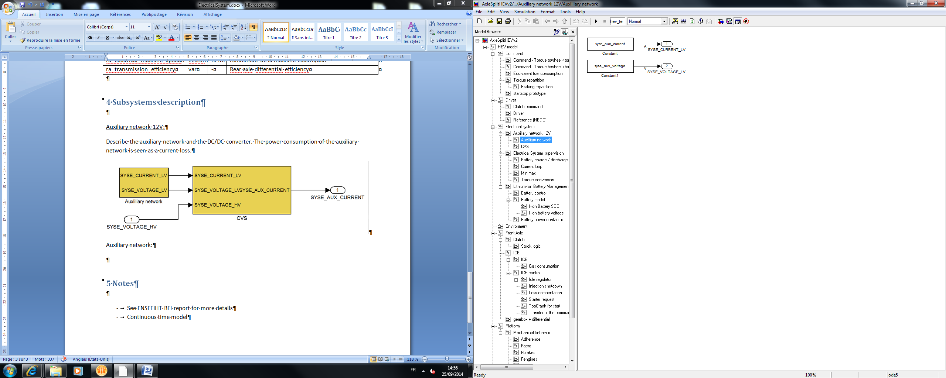

CVS

Converter DC/DC between the servitude and the power network.

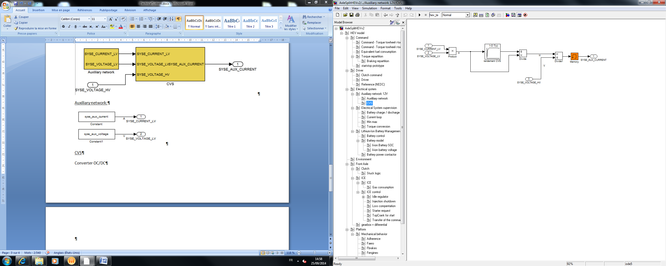

Electrical system supervision :

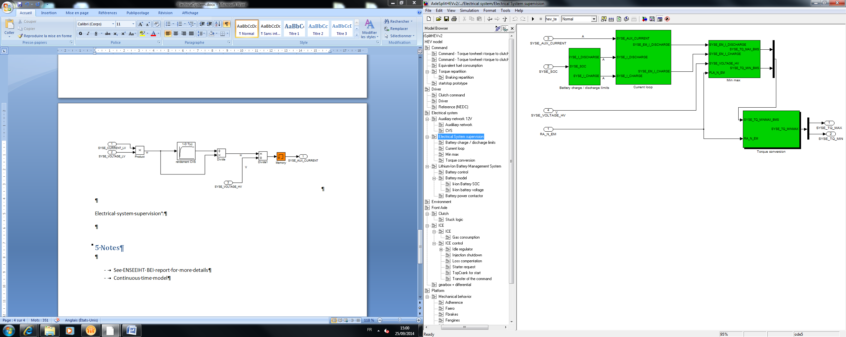

Discharge limits

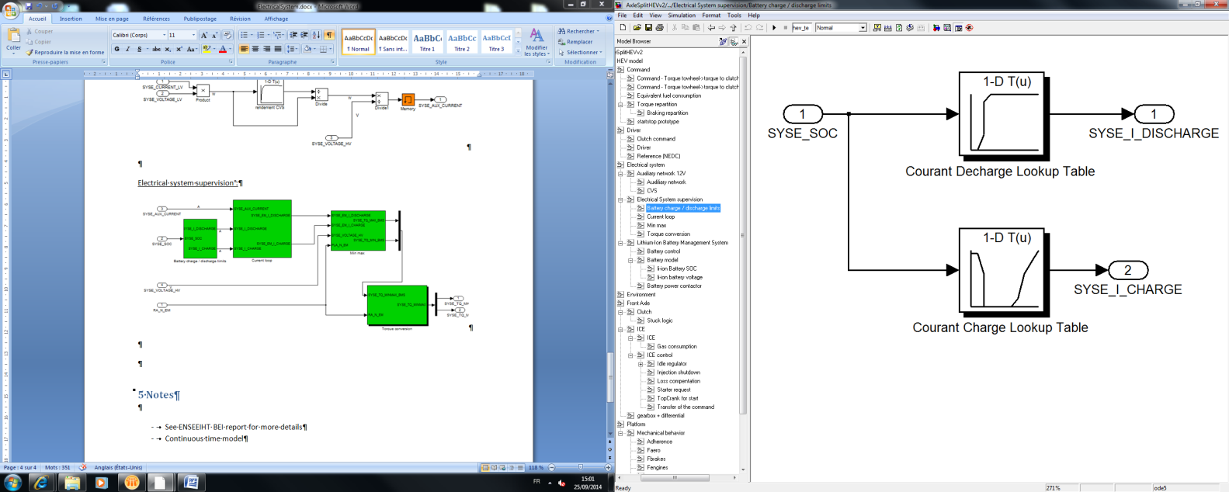

Current loop

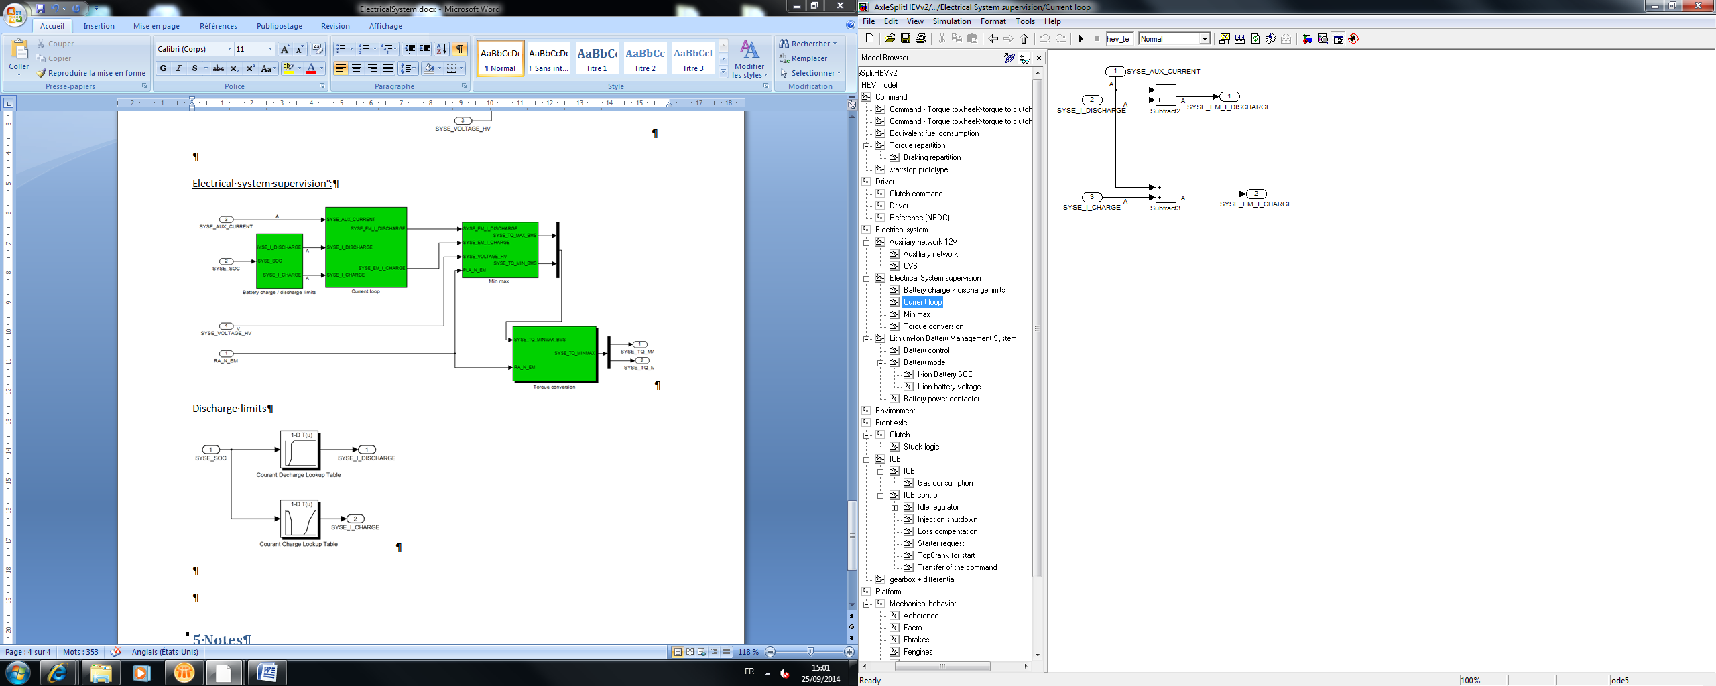

Min max:

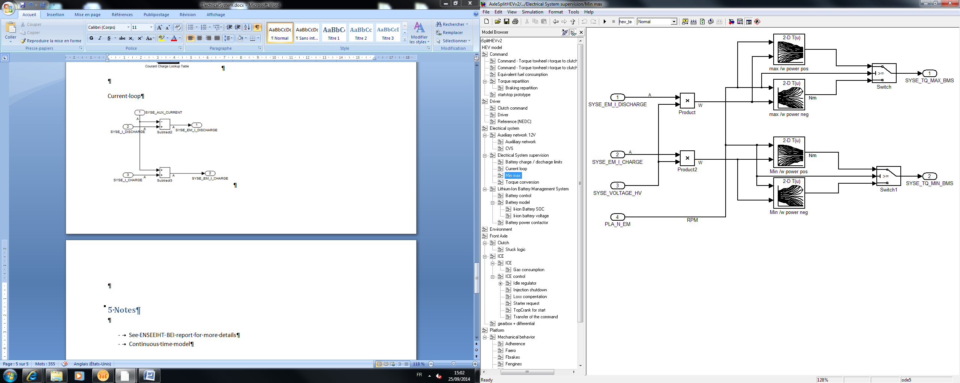

Torque conversion

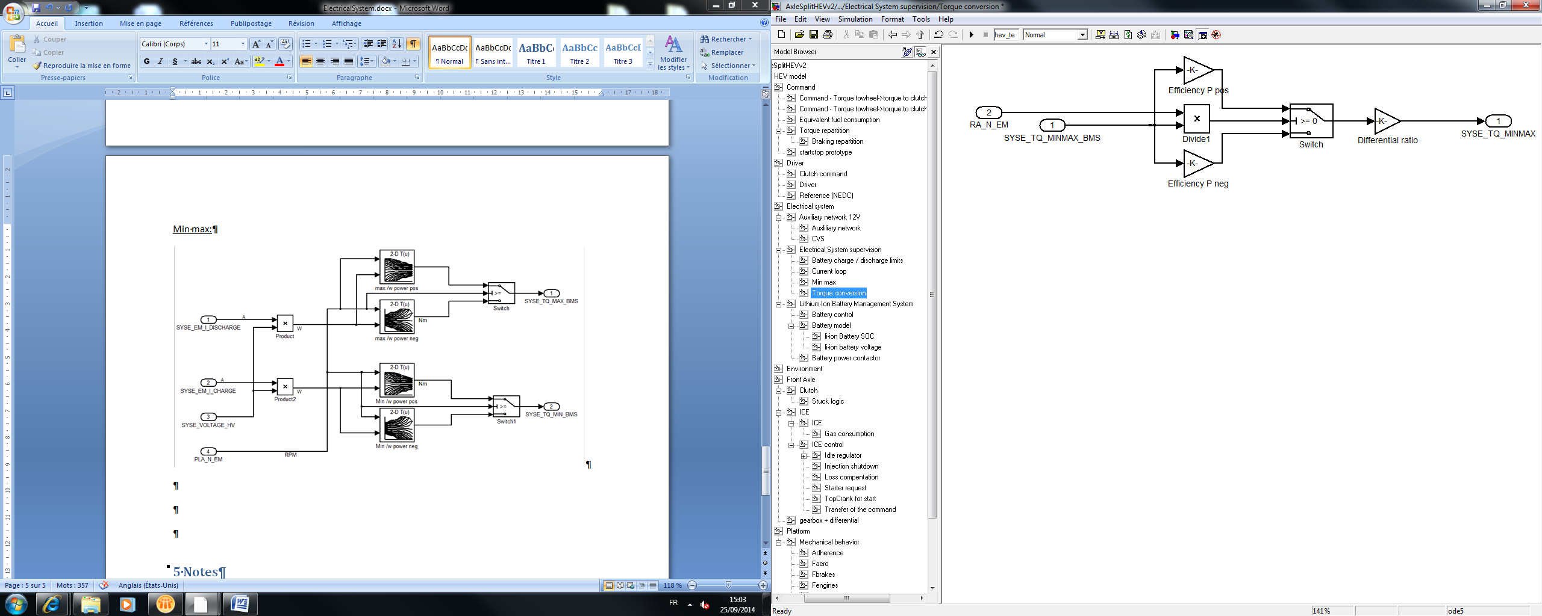

Lithium-Ion battery Management System

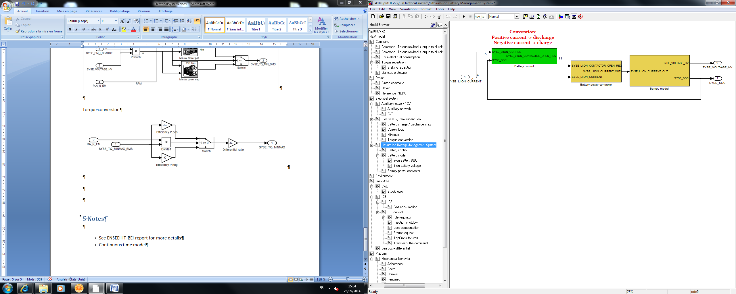

Battery control

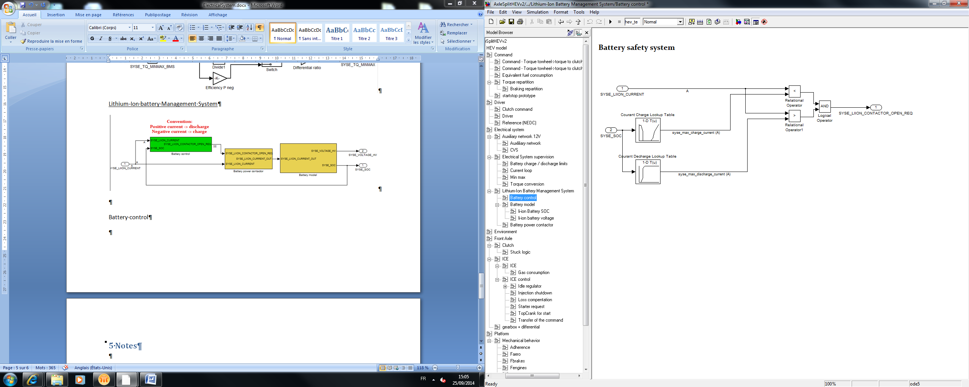

Battery power contactor

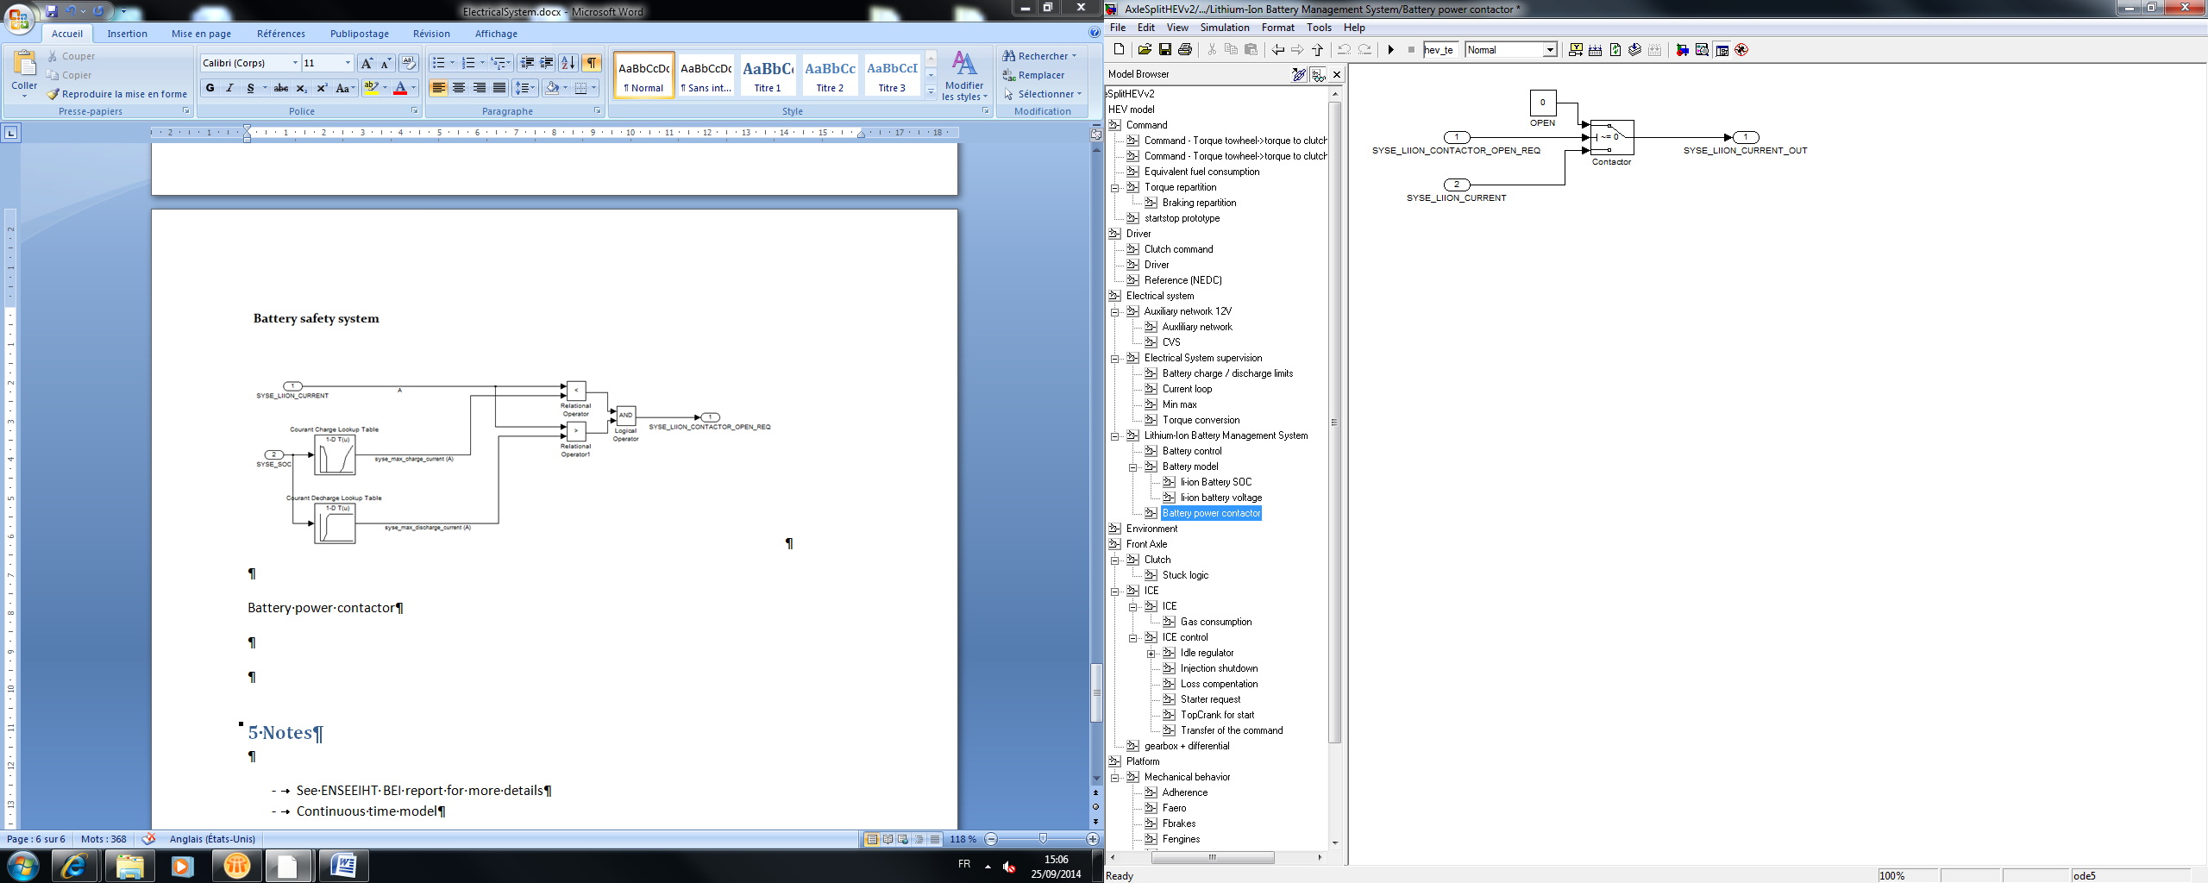

Battery model

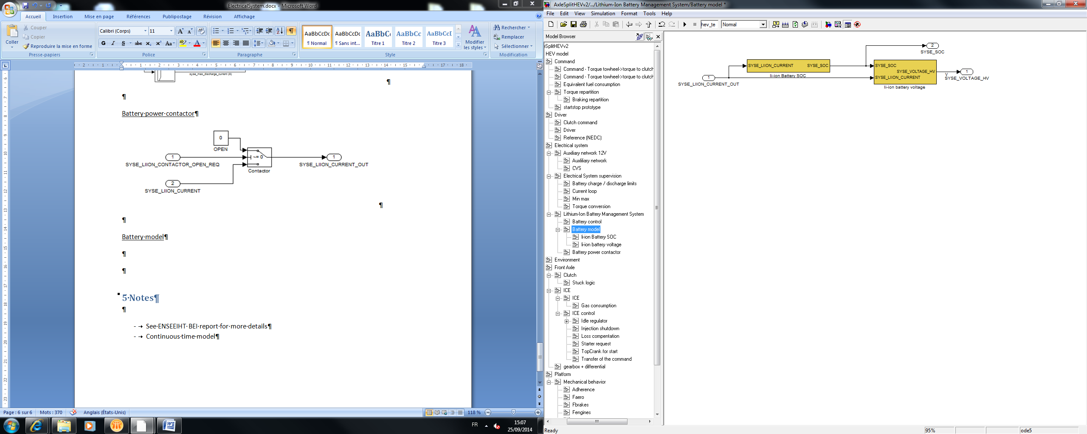

Li-ion battery SOC

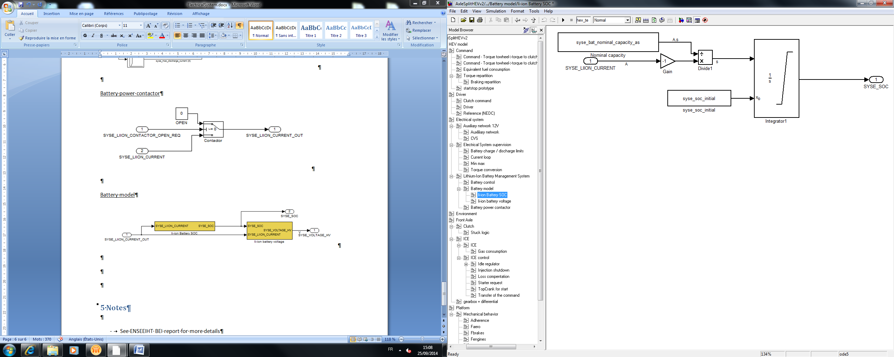

Li-ion battery voltage

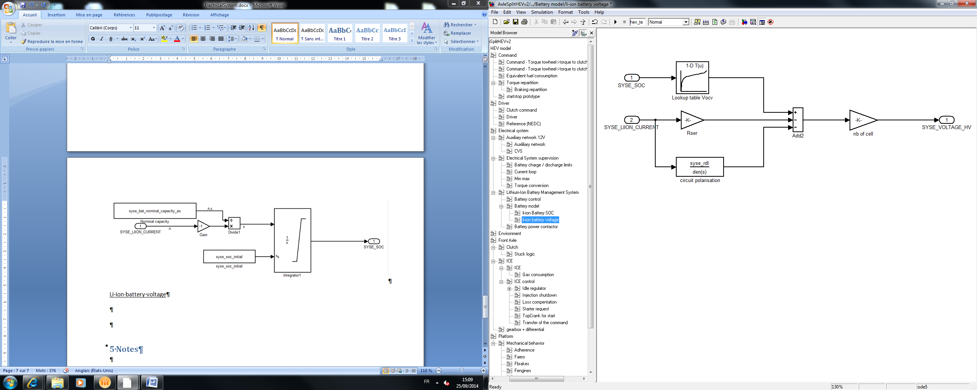

# 5 Discrete Model

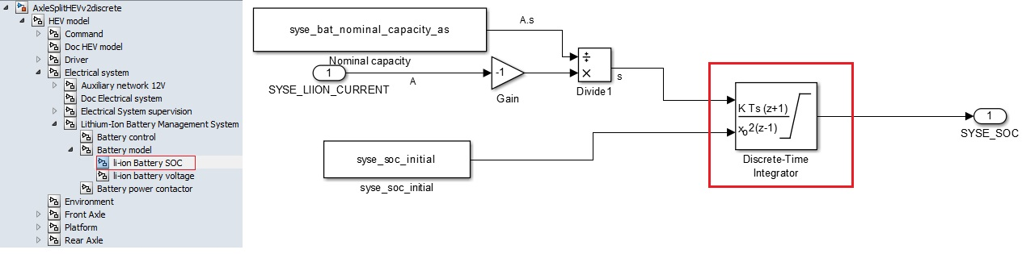

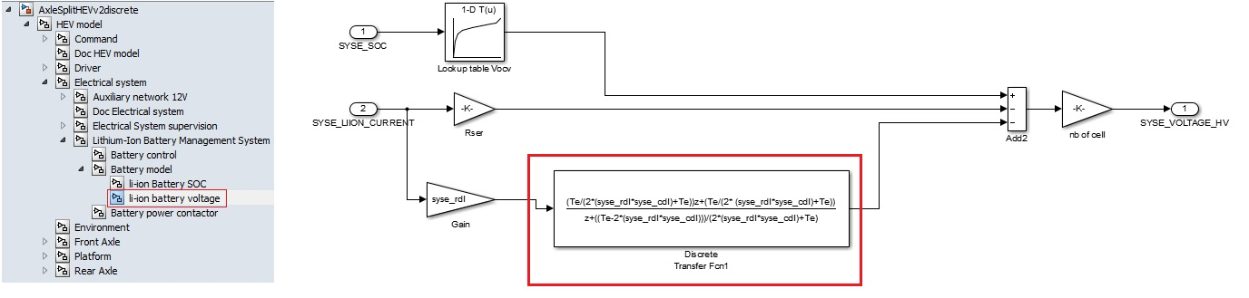

Same inputs, outputs and parameters. The only changes are in the red squares.

See part 5 (“Discrete model”) of the document “HEV model” to know how are made the discrete blocs.